Creational Design Patterns In Java
- Design

- Core Java

- java
by devs5003 - June 13, 20214
Last Updated on February 2nd, 2024
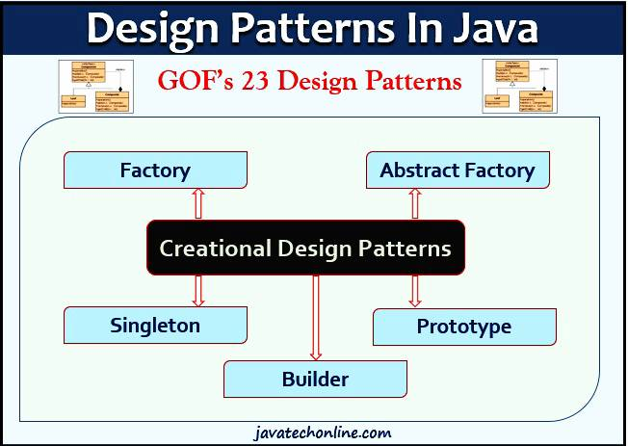As the first part of Design Patterns in Java, we will discuss about Creational Design Patterns in Java in this article. We have already covered the Introduction of Design Patterns in Java in a separate article. In the introductory part, we have already discussed about What, Why & advantages of Design Patterns. We will discuss five design patterns in total in this article that come under the category of Creational Design Patterns.
Creational design patterns deal with providing solutions to instantiate an object in the best possible way for specific situations. Let’s start with our topic ‘Creational Design Patterns in Java’ and other concepts related to it.
Table of Contents
- What are Creational Design Patterns in Java?
- What are the types of Creational Design Patterns in Java?
- Singleton Design Pattern
- Factory Design Pattern
  - Example
  - Benefits
  - Usage in JDK
- Abstract Factory Pattern
  - Example
  - Benefits
  - Usage in JDK
  - When to use
- Builder Design Pattern
  - Builder
  - ConcreteBuilder
  - Director
  - Product
  - Example
  - Another form/version of the Builder Pattern
    - Steps to create the Pattern
  - Example
  - When to use the Builder Pattern
  - Builder Pattern in JDK
- Prototype Design Pattern
  - Object Cloning
  - Example
  - When to Use
  - Usage in JDK
- Links to Other Design Patterns
  - Structural Design Patterns
  - Behavioral Design Patterns
- Links to OOPs Design Principles & SOLID Principles
  - OOPs Design Principles
  - SOLID Design Principles
ADVERTISEMENT

What are Creational Design Patterns in Java?
Creational design patterns provide solution to instantiate an object in the best possible way for specific situations.
What are the types of Creational Design Patterns in Java?
Generally, there are five well-known types of Creational Design Patterns in Java.
- Singleton Pattern
- Factory Pattern
- Abstract Factory Pattern
- Builder Pattern
- Prototype Pattern
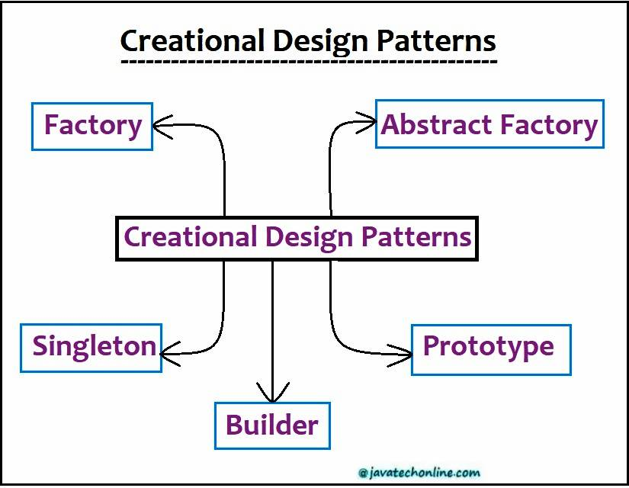
Now, let’s understand each Design Pattern one by one.
Singleton Design Pattern
From the definition, it seems to be a very simple design pattern, but when it comes to implementation, it creates a lot of execution concerns. Also, the implementation of Java Singleton pattern has always been a controversial topic among developers. Therefore, we have explained it in a separate article ‘Singleton Design Pattern In Java With All Scenarios‘. In that article, you will learn about Singleton Design Pattern in Java with all Scenarios, different ways to implement Singleton design pattern and some of the best practices for its usage.
Factory Design Pattern
The Factory design pattern is used when we have a super class with multiple sub-classes and based on input, we need to return one of the sub-classes. This pattern takes out the responsibility of instantiation of a class from a client program to the factory class. Moreover, we can apply Singleton pattern also on Factory class or make the factory method static.
Super class in factory pattern can either be an interface, or an abstract class, or a normal Java class.
Example
For example, let’s assume we are creating objects from a factory of Mobiles.
IMobile.java
public interface IMobile {

public void cost();
public void pictureCapacity();
public void batteryPower();
}
Lenovo.java
public class Lenovo implements IMobile {

@Override
public void cost() {
System.out.println("Lenovo Cost starts from 10000");
}

@Override
public void pictureCapacity() {
System.out.println("Lenovo camera capacity starts from 10 MP");
}

@Override
public void batteryPower() {
System.out.println("Lenovo battery power starts from 2500 MAh");
}
}
Samsung.java
public class Samsung implements IMobile {

@Override
public void cost() {
System.out.println("Samsung Cost starts from 6000");
}

@Override
public void pictureCapacity() {
System.out.println("Samsung camera capacity starts from 4 MP");
}

@Override
public void batteryPower() {
System.out.println("Samsung battery power starts from 1200 MAh");
}
}
MobileFactory.java
public class MobileFactory {

public MobileFactory(){

}

IMobile createMobile(String type){

IMobile mob=null;
if("len".equalsIgnoreCase(type)){
mob=new Lenovo();
System.out.println("Lenovo created");
}else if("sam".equalsIgnoreCase(type)){
mob=new Samsung();
System.out.println("Samsung created");
}
return mob;
}
}
FactoryTest.java
public class FactoryTest {

public static void main(String[] args) {
MobileFactory factory= new MobileFactory();

Lenovo len = (Lenovo)factory.createMobile("len");
len.batteryPower();

Samsung sam= (Samsung)factory.createMobile("sam");
sam.cost();
}
}
Output
Lenovo created
Lenovo battery power starts from 2500 MAh
Samsung created
Samsung Cost starts from 6000
Benefits
- Factory pattern offers an approach to code for interface rather than implementation.
- Factory pattern removes the instantiation of actual implementation classes from client code, making it more robust, less coupled and easy to extend. For example, we can easily change class implementation because client program is unaware of it.
- Factory pattern also provides abstraction between implementation and client classes through inheritance.
Usage in JDK
- util.Calendar, ResourceBundle and NumberFormat getInstance() methods use Factory pattern.
- valueOf() method in wrapper classes like Boolean, Integer etc.

Abstract Factory Pattern
Almost similar to Factory Pattern, except the fact that it’s more like factory of factories. If you are familiar with factory design pattern in java, you will notice that we have a single Factory class that returns the different sub-classes based on the input provided. Generally, factory class uses if-else or switch-case statement to achieve this. However, in Abstract Factory pattern, we get rid of if-else block and have a factory class for each sub-class and then an Abstract Factory class that will return the sub-class, based on the input factory class.
In fact, An abstract factory is a factory that returns factories. Why is this layer of abstraction useful? A normal factory can be used to create sets of related objects. An abstract factory returns factories. Hence, an abstract factory is used to return factories that can be used to create sets of related objects.
For example, you could have a Honda factory that returns car objects (Brio, Civic, etc.) associated with a Honda factory. You could also have a Hyundai factory that returns car objects (Santro, EON) associated with a Hyundai factory. However, we could create an abstract factory that returns these different types of car factories depending on the car that we were interested in. Furthermore, we could then obtain car objects from the car factories. Via polymorphism, we can use a common interface to get the different factories, and we could then use a common interface to get the different cars.
Example
For example, let’s assume the previous example of Mobiles. However, this time we will create the objects using one extra layer of abstraction.
IMobileFactory.java
public interface IMobileFactory {

IMobileFactory createMobile(String type);
}
MobileFactory.java
public class MobileFactory implements IMobileFactory {

@Override
public IMobileFactory createMobile(String type) {

IMobileFactory mob = null;
if ("lenf".equalsIgnoreCase(type)){
mob= new LenovoMobileFactory();
} else if ("samf".equalsIgnoreCase(type)){
mob= new SamsungMobileFactory();
}
return mob;
}
}
LenovoMobileFactory.java
public class LenovoMobileFactory extends MobileFactory {

Lenovo createLenovoMobile(){
return new Lenovo();
}
}
SamsungMobileFactory.java
public class SamsungMobileFactory extends MobileFactory {

Samsung createSamsungMobile(){
return new Samsung();
}
}
AbstractFactoryTest.java
public class AbstractFactoryTest {

public static void main(String[] args) {
MobileFactory factory= new MobileFactory();
LenovoMobileFactory lmf= (LenovoMobileFactory)factory.createMobile("lenf");
Lenovo ln= (Lenovo)lmf.createLenovoMobile();
ln.pictureCapacity();
}
}
Output
Lenovo camera capacity starts from 10 MP
Benefits
- Abstract Factory pattern also offers an approach to code for interface rather than implementation.
- Abstract Factory pattern is “factory of factories” and can be easily extended to accommodate more products. For example, we can add another sub-class ‘Dell’ and a factory ‘LaptopFactory’.
- Abstract Factory pattern is robust and it eliminates conditional logic unlike Factory pattern.
Usage in JDK
- xml.parsers.DocumentBuilderFactory#newInstance()
- xml.transform.TransformerFactory#newInstance()
- xml.xpath.XPathFactory#newInstance()
When to use
When a family of related objects is designed to be used together, and you need to enforce this constraint.

